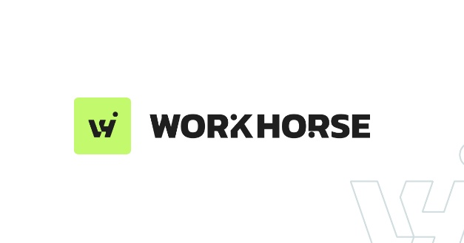

Software Engineer – Automation & Operations
Role Overview
We are looking for a hands-on, technically capable Software Engineer to support the ongoing development, maintenance and operation of our software platform. Our core platform is built in PHP, uses MySQL databases and runs on AWS.
The primary focus will be delivering software changes from Jira tickets, working with our existing AI-assisted development tools to scope, build, review, test and deploy well-engineered solutions.
A key part of the role will be supporting our helpdesk team with technical investigations and developing the automation that helps resolve customer issues. This includes improving our existing AI-powered RAG pipeline and progressively introducing automated response drafting, resolution and escalation.
Additional responsibilities include database management, improving development automation, monitoring our AWS infrastructure and supporting the implementation team with technical challenges.
This is a broad, practical engineering role, working closely with the existing leadership and development teams, with support from our external infrastructure specialists.
Key Responsibilities
- Software Development: Take ownership of Jira development tickets, help scope technical requirements and deliver software improvements and bug fixes.
- AI-Assisted Development & Code Quality: Use and improve our existing AI-enabled development workflows, reviewing generated code to ensure changes are well-targeted, maintainable, secure and properly tested. Understand the existing codebase and maintain engineering standards.
- Helpdesk Support & Automation: Support the helpdesk team with technical investigations and complex customer issues. Maintain and develop our existing AI-powered RAG pipeline, improving how tickets are enriched with relevant information and introducing automated response drafting, resolution and escalation where appropriate.
- Database Management: Write and maintain SQL, manage database updates, schema changes and migrations, and ensure database integrity and performance.
- Deployment & Automation: Maintain and improve existing CI/CD pipelines, automate repetitive development tasks and support reliable software releases.
- Infrastructure Monitoring: Implement and maintain AWS monitoring and alerting, covering system availability, memory utilisation, CPU capacity, performance and potential issues.
- Operational & Implementation Support: Investigate technical issues, proactively identify problems, support the implementation team in developing technical solutions to customer requirements, and coordinate with our outsourced infrastructure team where specialist support is required.
Candidate Profile
A capable mid-level software engineer with strong SQL skills, sound software engineering fundamentals and practical experience with deployment processes, automation and cloud environments.
Someone comfortable working across a broad technical remit, taking ownership of tasks and improving existing systems rather than always building from scratch.
They should be enthusiastic about AI, keen to explore how AI-assisted tools can improve software development, customer support and operational efficiency, and confident in assessing the quality and reliability of AI-generated outputs.
The ideal candidate will be a practical problem-solver, comfortable working independently on defined tasks while collaborating closely with the wider team.
PHP experience would be beneficial but is not essential.

